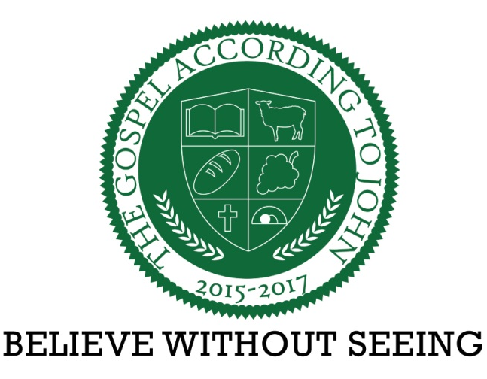

November 29, 2015

Dr. James Carroll, Senior Pastor

John 1:1-2 | The One Before the Beginning

Overview - Will you believe in the One who was before the beginning?

1. Believe in Jesus because He is the Word.
2. Believe in Jesus because He is eternal.
3. Believe in Jesus because of His relation to God.
4. Believe in Jesus because He is God.

